STATEMENT LETTER

The author of the manuscript submitted to be published in the Magna Medica of APKKM (Asosiasi Pendidikan Kedokteran Dan Kesehatan Muhammadiyah, Asociation of Medicine And Health Education Muhammadiyah), entitled:
Hubungan Luas Ventilasi dan Pencahayaan Alami Rumah terhadap Tingkat Kepositifan Sputum BTA pada Penderita TB Paru di Puskesmas Tlogosadang
Stating exactly that:
- The manuscript with the title above is ORIGINAL MANUSCRIPT, NOT PLAGIATED, and does not contain plagiarism
- The manuscript with the title above does not contain data falsification
- The manuscript has NEVER BEEN and ISN'T BEING IN PUBLISHING PROCESS by other journals in any other form or sent to other journals for publication.
- All names listed in the ownership line of the manuscript agree with the final form of the proposed manuscript
- The author hereby submits the complete copyright to Magna Medica to reproduce, distribute, and sell this manuscript publication as part of the Magna Medica journal.
- All consequences due to this statement's untruth are the author's responsibility and not the responsibility of the Magna Medica journal.

Surabaya, 28 November 2020
First author : Name : Vina Rahmatika
Institution : Universitas Muhammadiyah Surabaya
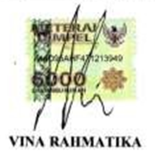
HP / email : 082138427586 / vinarahmatika47@gmail.com
Signature :

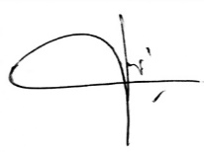
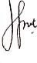
Co-author 1 : dr. Musa Ghufron, MMR Signature
Co-author 2 : dr. Nenny Triastuti M,si Signature

