APPLICATION LETTER

Dear,

Chief in Editor
MAGNA MEDIKA: Berkala Ilmiah Kedokteran dan Kesehatan
APKKM (Asosiasi Pendidikan Kedokteran dan Kesehatan Muhammadiyah-Muhammadiyah Medical and Health Education Association)

Faithfully,

We at this moment submit a manuscript with the title:

Accurations Comparison of FNAB and Anatomic Phatology Biopsy in Diagnosis of Thyroid Nodul at General Hopital Pare Kediri 2015-2019
for consideration, published in the journal MAGNA MEDIKA: Berkala Ilmiah Kedokteran dan Kesehatan. We attach a statement of originality and submission of copyright to the manuscript with that title.
Thus, We thank to the attention of the Editor.

Surabaya, December 22 2021

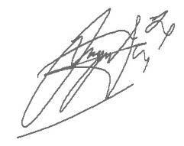
First Author/Corresponding Author,

Muhammad Tegar Nugraha

