INVESTIGATION OF BEHAVIOUR AND ATTITUDE ABOUT FACEBOOK IN AN ENGLISH FOR COMMUNICATION COURSE AND STUDENT NEEDS FOR SPEAKING TASKS
Thiratchapon Kamsa-ard.
Udon Thani Rajabhat University
Thailand
Thiratchapon@udru.ac.th

Abstract
This study aimed to investigate the needs for speaking tasks of Thai undergraduate non-English major freshmen students and to learn their behavior when using Facebook in an English for Communication course at Udon Thani Rajabhat University. Forty-two participants were purposively selected during the second semester of the 2017 academic year. A questionnaire and a semi-structured interviews were used used as research instruments. The results showed that the participants agreed that using a closed group on Facebook was beneficial (score of 4.8) and the participants were satisfied using Facebook to do the speaking tasks of this course (score of 4.49). However; the participants did not get enough feedback (score of 1.84) from their teacher on Facebook. They also wanted the teacher’s feedback on their video presentations )2.07). 2.3% of the students practiced conversation in pairs for more than 90 minutes before recording their video. 9.3 % of the students took more than 1 hour for individual practice. Furthermore, five students were interviewed to learn their problems and needs in learning English for communication.

Keywords: Task-based Learning and Teaching, Needs Analysis, Facebook, Speaking Skills

Introduction
Speaking is an important skill for communication. Effective communication needs understanding of a message in a second language (L2) ( Nunan, 1998). Therefore, language learners need to have the skills necessary to describe, explain, justify their arguments, ask for information, orally present, request help and interact with others. It is difficult for non-native speakers to understand all of a message. It is necessary for language instructors to teach an L2 and use appropriate approaches for speaking development. For example, choosing approaches to teach speaking is difficult. For decades, there were several approaches and principles to teach a target language, such as a grammar-translation, technology (e.g., recorded media) and communicative language learning approaches. This study aims to implement a communicative language teaching approach and task-based instruction to enhance student comprehension, and give students the abilities to manipulate, produce or interact while using a target language effectively. It also includes a focus on meaning rather than form (Nunan, 1988). Students are required to learn about asking and responding. However, this seems insufficient for practicing English with Thai teachers and friends in the classroom. There are several problems leading to unsuccessful English learning for Thai students. Khunsamrong (2008) found that Thai EFL students are influenced by growing up in an environment where they use their Thai mother tongue. Thai is the official language of the nation. Students do not see the importance of learning English. They do not seek opportunities to practice English outside of their classes.
Needs analysis
Needs analysis plays an important role in language teaching and learning. Nunan (2004) that found that need analysis involves methods to investigate the language content and instructional processes for particular groups of students. It refers to when a target situation is analyzed depending on a particular group of students. Richards (1984) stated that needs analysis can be described as language requirements in the content of a language learning and teaching course. It includes an objective to learn the target language and gain language proficiency. Hutchinson and Waters (1987) defined needs analysis in ESP is an English learning approach using a target situation in the course. Moreover, course development should be based on identifying student needs. Student needs focused on necessities, wants, and things that are lacking.
There have been several studies about needs analysis in language learning using various approaches. Richterich and Chancerel (1978) proposed systemic approaches for identifying for immediate, present and future needs of adults learning a foreign language. Likewise, Munby (1978) proposed a way to identify target situational needs. It can show a student’s ability to understand or use language in a target situation. Yalden (1987) proposed that needs analysis can be seen in a second language requirements survey in forms such as general background information, language needs, learning style and preferences. Robinson (1991) studied immediate, present and future needs. Tudor (1996) focused on learner-centeredness. In the same way, Richards and Long (2001; 2005) also defined leaner needs. Moreover, Tomlinson (1998) presented the needs of learners, teachers and administrators. Jordan (2011) mentioned that needs analysis emphasizes the requirements of stakeholders for course and material design. The needs of people such as educators, subject specialists, language course designers, and teachers and learners have been addressed.

In Thailand, there have been few studies using needs analysis for either general English or English for specific purposes. Chuangsakul (2000) identified the English learning needs for police constable students. Klaichim and Charumanee (2009) studied the problems and needs of English Teaching and Learning at the Institutes of Physical Education. Saiyan (2010) studied the needs for the language use in the field of English learning for Khon Kaen University. The drivers were needs analysis and English course guideline. Siriket (2011) studied the needs for English learning for English used by photocopyists. These studies focused on student problems, suggestions and guidelines. However, after the students were identified, speaking tasks were implemented into their classes and the results were analyzed. According to the ultimate goal of this study, the aim was to identify student needs in terms of necessities, wants and deficiencies.
Task-based Instruction
Task-based language teaching emerged over a period of years (Willis, 1996; Larsen-Freeman, 2000; Bygate, Skehan & Swain, 2001; Skehan, 2003; Nunan, 2004; Ellis 2003). Tasks can be defined in several ways. They refer to language activities that allow students solve problems in the target situation. These are real world activities that focus on communication.

Ellis (2003) stated that tasks aim to focus on meaning rather than form to learn a second language. That is an important characteristic of language tasks. Another characteristic of language learning is fluency. Finochhoiraro and Brumfit (1983) stated that fluency is needed to complete any task. Additionally, Long (2014) identified the characteristics of the tasks that a student needs to master to gain enough information to complete their work. All students in a group have unique information to contribute. It is a two-way process. Nunan (2004) proposed that characteristics of tasks are a goal to gain competency in a target language beyond that achievable in a classroom. These tasks consist of activities where two students share information for completing a given assignment by asking for and giving information while using their real world knowledge to solve problems associated with a specific situation.

Tasks in speaking
Speaking is “a process of building and sharing meaning through the use of verbal and non-verbal symbols in variety of contexts” (Chaney, 1998, p 13). This refers to how a speaker conveys the meaning that (s)he aims to present with or without symbols. Use of speaking tasks may be useful. Doughty and Pica (1986) examined the production of longer spoken sentences and negotiation of meaning in pairs and in group work. The aim was to use interactive tasks and to compare the results with the teacher fronted-learning. This finding showed that students improved their speaking and were more confident.

In Thailand, there have been few studies about speaking tasks. Singwongsuwat (2012) rechecked tasks and evaluation in speaking skills using interviews and role-play. The findings showed that it can be possible to improve speaking by using a tasks in non-scripted role-playing, if a speaking rubric is suitable for communicative situations. Khamhien (2010) investigated the factors that have influenced Thai EFL learning.
Often, Thai EFL teachers are not qualified. CLT in Thailand fails because the mediators, Thai EFL teachers, cannot manage the communicative activities of Thai EFL learners. Teachers need to match the materials with the learners’ language skills, personal lives, and real world situations. Khamhien suggested that instructors need to improve their teaching abilities, especially in testing and evaluation through communication. It is not easy to anticipate the problems and devise strategies to enhance learners’ performance. Therefore, this study proposed an investigation of student needs to identify the real needs of students after they implemented speaking tasks, and their level of satisfaction. Teachers and their students can create a closed group on Facebook to share information and submit their assignments.

Facebook in language teaching and learning
Education is changing in the modern world. However, innovation affects more than technology. Approaches to teaching are important as well as the use of technology to gain better learning outcomes. Barette and Shama (2007) enumerated the advantages of using technology in ESL as 1) motivation where the teacher provides interesting tasks, such as games or multimedia exercises, 2) interactivity, 3) timely and interactive feedback, and, 4) teacher support of students’ autonomous learning.

In this study, both synchronous and asynchronous communication were used. Synchronous communication refers to communication that can be achieved during online chats (e.g., Facebook messenger). In contrast, asynchronous communication refers to communication that is done during discussion forums, collaborative workspaces such as Google docs, via e-mail, in blogs or through voice threads. In this study, student work was kept in a closed group on Facebook for speaking tasks in face-to-face and online classes. This motivated students to better learn their target language. Akbari, Eghtesad, and Simons (2001) investigated student attitudes after using social networks for English language learning in Malaysia. Their findings showed that the participants had positive attitudes about using Facebook. Moreover, Facebook was an effective tool for encouraging linguistic knowledge and performance. Shih (2013) examined the effect of using blended learning via Facebook and peer assessment. Blended learning was implemented in writing assignments in an 18 week English for Business Communication course. During weeks 9-17, the students needed to assess their peers on Facebook. They also needed to attend F2F classes for monitoring by their instructor. Data collection was from pre- and post-tests, interviews and questionnaires. The post-test findings showed that the participants improved their knowledge in the blended learning course. Questionnaires showed positive results of integrating blended learning. It was effective and interesting. The participants were satisfied with the implementation of blended learning in English classes for specific purposes. Interviews showed positive attitudes about implementing Facebook and blended learning into the course. There were three groups of participants with different English proficiencies. Selecting teaching approaches enhanced student achievement because using appropriate teaching techniques is important. Facebook use is a new way to communicate with students in the 21st century. Pandumrongsit (2013) found that 78% of 230 Thai students were online on Facebook more than 3 hours/day. This was the reason that the researcher tried to blend Facebook and teaching spoken language. Chaiparn et al. (2014) stated that there was a positive attitude of using Facebook in a writing course. In an English speaking course, Kijaruk (2016) found that Thai teachers and students demonstrated positive attitudes about using Facebook in a speaking class monologue. The students needed to prepare a script before telling their stories. However, in this study the researcher used information and individual tasks. In this course, the researcher tried to put communicative language teaching activities into practice. Therefore, scripts were not have been used in this course.

Research Questions
The current study addressed two research questions. They are:

1) What are the needs of students in an English for Communication course at Udon Thani Rajabhat University for speaking tasks?
2) To what extent do the students in this English for Communication course use Facebook for doing their speaking tasks?
Purposes of the study
The current study had two aims. They are:
1) To explore the needs of students in an English for Communication course at Udon Thani Rajabhat University in their speaking tasks.
2) To identify their behavior of using Facebook in an English for Communication course in speaking tasks.
Methodology
Participants
Participants were first year students enrolled in an English for Communication course at Udon Thani Rajabhat University during the second semester of the 2017 academic year. None were English majors. There were two groups of participations. The first group was comprised of 22 accounting students (M=5, FM=17). The second group consisted of 20 participants from the Thai studies department.

Research Procedures
In this session, the researcher implemented a speaking task in an English for Communication course. It is a required subject at Udon Thani Rajabhat University. The objectives of the course focus on interactive skills, listening and speaking. The course is comprised of six units.
- Greetings and introductions
- Describing places, things, and people
- Asking and giving directions
- Shopping
- Making an appointment
- Expressing feelings, opinions and making suggestions.
There were two speaking tasks in this course. The students needed to practice in class and upload their videos on Facebook. These activities took place over a four-month period. The students needed to practice in and outside class.

Table 1 An example of the functions of speaking tasks and the number of group members

From Table 1, there were two things that the students need to do for their assignments in class and at home. They were:
1) Work in pairs or groups of three depending on the given situation. For example, the task called “Introducing Oneself” is used to start the class. The students need to learn to ask for basic information using questions prepared by the teachers, e.g., What is your name? What do you do in your free time? Then, the students need to use this information to tell their story and make a video.

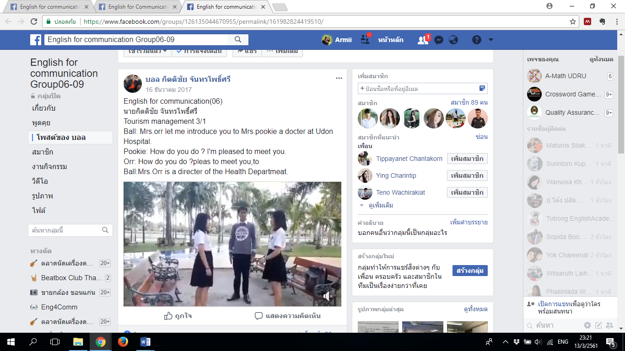

Figure 1. An example of pair work or working in groups of three on Facebook (closed group)

Function of speaking task | Type of work
Introducing oneself | 1.Pair work (in class)  2.Individual work (video at home)
Introducing someone else | Group of three (video at home)
Describing people | 1.Pair work (in class)  2.Individual work (video at home)
Asking and giving direction | Pair work (video at home)
Telephoning | Pair work (video at home)
Additionally, there were two different sets of information. The partners need to collect information as a jigsaw exercise and make the information clear (e.g., a tourist and a police officer).

2) Individual work refers to work of a single person and then making a video and uploading it to Facebook at home using the target situation. The target situation was provided by the teacher.

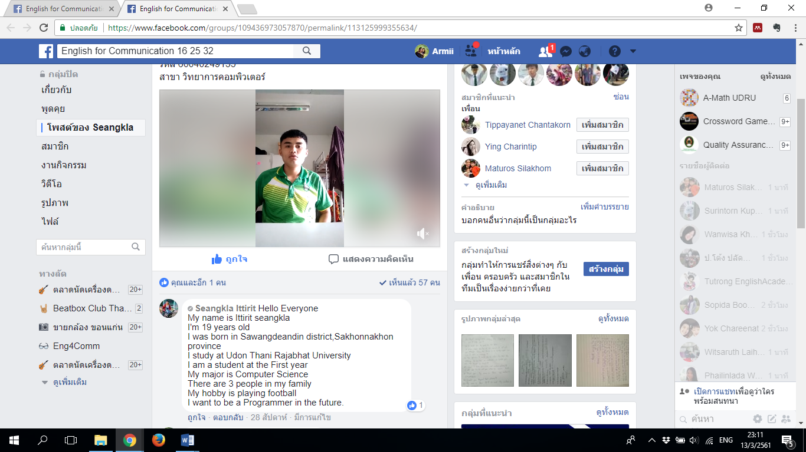

Figure 2. An example of individual work on Facebook (closed group)

Task procedure
Students learned a situational conversation (greetings and introduction, asking for and giving directions, telephoning, describing places and people, and buying things).
e.g.. : A acts as a shop keeper.
B acts as a customer.
1) They learned relevant expressions, grammar use and vocabulary.
2) They needed to act and practice with their partners to record the conversation.
3) Each assumed a different role to complete the tasks.
4) The teacher chose three groups to perform in front of the class and give feedback.

Data Analysis:
In this study, the researcher separated data analysis into two parts, including, 1) the data from the analysis of needs in speaking tasks and behavior using Facebook. This study used percentages in data analysis to analyze student needs. The data was derived from questionnaires and interviews and it was interpreted using SPSS.

Findings and Discussion
There are 5 tables which demonstrate the findings of Function in using Facebook, Students attitude on using Facebook, Function of speaking task, the frequency of speaking practicing before uploading their speaking task videos.

In the table 2, the results showed that the participants agreed that using a closed group on Facebook was beneficial (4.86*). The participants were satisfied using Facebook to do the speaking tasks in this course (4.49*) (Asterix (*) shows the interesting data). In addition, even though the students were shy. However, they wanted the passing scores. This is the factor that motivated the students to upload their video.
Function in using Facebook | Freq. | Valid % | S.D.
They liked using Facebook in this course | 43 | 4.49* | 1.261
The closed group on Facebook was beneficial for English for communication | 43 | 4.86* | .516
They used Facebook messenger | 43 | 4.37 | 1.398
They had problems using Facebook in this course | 43 | 1.00 | .00
They were shy to upload their videos | 43 | 3.60 | 1.72
They were shy but the score was the reason that they needed to upload | 43 | 4.53* | 1.22
Table 2. Functions using Facebook

Students attitude on using Facebook | Freq. | Valid % | S.D.
They received enough feedback from the teacher | 43 | 1.84* | 1.60
They wanted teacher feedback on their video | 43 | 2.07* | .34
They want more situational videos | 43 | 3.35 | 1.38

Table 3. Student attitudes about using Facebook
In table 3 However, the participants did not gain enough feedback (1.84) from the teacher on Facebook. They also wanted the teacher’s feedback on their videos (2.07).
Function of speaking task | individual  / pair work | Mean | S.D.
Introducing oneself | Ind. (pair work in class) | 4.30* | 1.036
Introducing someone else | pair work | 3.21 | 1.206
Describing people | Ind. (pair work in class) | 3.40 | 1.365
Asking for and giving directions | pair work | 2.79 | 1.265
Telephoning | pair work | 2.93 | 1.298
Table 4. Sample speaking task
In table4, this table gives information about speaking tasks in and outside of class. Students were most satisfied with the task, “Introducing Oneself”.

 | Freq. | % | Valid % | Cum. %
Valid - | 3 | 7.0 | 7.0 | 7.0
1 | 1 | 2.3 | 2.3 | 9.3
10 | 2 | 4.7 | 4.7 | 14.0
15 | 8 | 18.6 | 18.6 | 32.6
2 | 2 | 4.7 | 4.7 | 37.2
20 | 3 | 7.0 | 7.0 | 44.2
3 | 2 | 4.7 | 4.7 | 48.8
30 | 6 | 14.0 | 14.0 | 62.8
40 | 2 | 4.7 | 4.7 | 67.4
45 | 2 | 4.7 | 4.7 | 72.1
5 | 6 | 14.0 | 14.0 | 86.0
50 | 2 | 4.7 | 4.7 | 90.7
6 | 1 | 2.3 | 2.3 | 93.0
60 | 2 | 4.7 | 4.7 | 97.7
90 | 1 | 2.3 | 2.3 | 100.0
total | 43 | 100.0 | 100.0
Table 5. The number of students and practice hours in pairs
In the table 5, 2.3% of the students practiced their conversations in pairs for more than 90 minutes before recording their video.
 | Freq. | % | Valid % | Cum. %
Valid - | 3 | 7.0 | 7.0 | 7.0
1 | 1 | 2.3 | 2.3 | 9..3
10 | 8 | 18.6 | 18.6 | 27.9
15 | 3 | 7.0 | 7.0 | 34.9
2 | 2 | 4.7 | 4.7 | 39.5
20 | 4 | 9.3 | 9.3 | 48.8
28 | 1 | 2.3 | 2.3 | 51.2
3 | 4 | 9.3 | 9.3 | 60.5
30 | 3 | 7.0 | 7.0 | 67.4
40 | 1 | 2.3 | 2.3 | 69.8
5 | 5 | 11.6 | 11.6 | 81.4
50 | 4 | 9.3 | 9.3 | 90.7
60 | 4 | 9.3 | 9.3 | 100.0
total | 43 | 100.0 | 100.0
Table 6. The numbers of the students and individual practice hours

According to the length of student practice in their speaking tasks, the length of time practicing in pairs and individually differed by 66 minutes. The total practice time in pairs was 907 minutes. However, individual practice time was 841 minutes over six weeks. Passing scores are the primary student motivators. Additionally, the data from the interview indicated from the students who took that from 90 minutes for in pairs before recording their videos. They were close friends with different English proficient levels.
Conclusions
The teacher can learn from student needs. This study found that student needs can be interpreted in terms of necessities, wants, and things that are deficient.
1) Necessities refers to the opportunity to practice speaking in and outside class.
2) Wants refers to feedback from the teacher. The students didn’t receive enough feedback.
3) The students were not entirely hones in making student videos. Some students prepared and read scripts. This is not the communicative language teaching approach. In the next study, the researcher plans to focus more on the student speaking problems.
References
Ellis, R. (2003). Task-Based Language Learning
and Teaching. Oxford: Oxford
University Press.
Hutchinson, T. & Waters, A. (1987). English
for Specific Purposes. Cambridge:
Cambridge University Press.
Jindapitak, N. (2010). An attitudinal study of varieties of English: voices from Thai university English learners. (Master of Arts Thesis) Prince of Songkla University.
Kamkien, A. (2010). Teaching English speaking skills and English speaking tests in the Thai contexts: A reflection on Thai perspective. English Language Teaching, 3, 184-190.
Khunsamrong, S. (2008). A Study of the
Problems Faced by Thai Students in
Acquiring English with Specific
Reference to the First Year Students at
Northern Campuses of
Mahachulalongkornrajavidyalaya
University. The University of Pune,
India.
Nunan, D. (1998). Language Teaching
Methodology. London: International
Book Distributers Ltd.
Nunan, D. (2004). Task-Based Language
Teaching. Cambridge: Cambridge
University Press.
Noom-ura, S. (2013). English teaching problems in Thailand and Thai teachers’ professional development needs. English Language Teaching, 6(11), 139-147.
Sawaengmongkon, (2013). Teaching suprasegmental features of spoken English through films to develop listening achievement of learners. FLLT conference proceedings, 2(1), 570-577.
Sharma, P. & Barrete, B. (2007). Blended
Learning: Using Technology in and
Beyond the Language Classroom.
Oxford: Macmillan.
Richards, J. (1984). Language Curriculum
Development. RELC Journal, 15(1), 1-29.
Saitakham, K., (2000). Enhancing English listening skill through websites practicing: a study of Thai EFL university students. IPEDR, (47), 11, 50-53.
Wiriyachitra, A. (2002). English Language
Teaching and Learning in Thailand in
this Decade. Retrieved February 9, 2016
from http://citeseerx.ist.psu.edu/viewdoc/download?doi=10.1.1.475.4155&rep=rep1&type=pdf
Yalden, J. (1987). Principles of Course for
Language Teaching. Cambridge:
Cambridge University Press.

