JKMI-literatur review Dwiki -
PI.docx
by Universitas Ahmad Dahlan Yogyakarta 23

Submission date: 24-Jun-2025 01:40AM (UTC+0700)
Submission ID: 2704839806
File name: JKMI-literatur_review_Dwiki_-_PI.docx (272.26K)
Word count: 6039
Character count: 41237

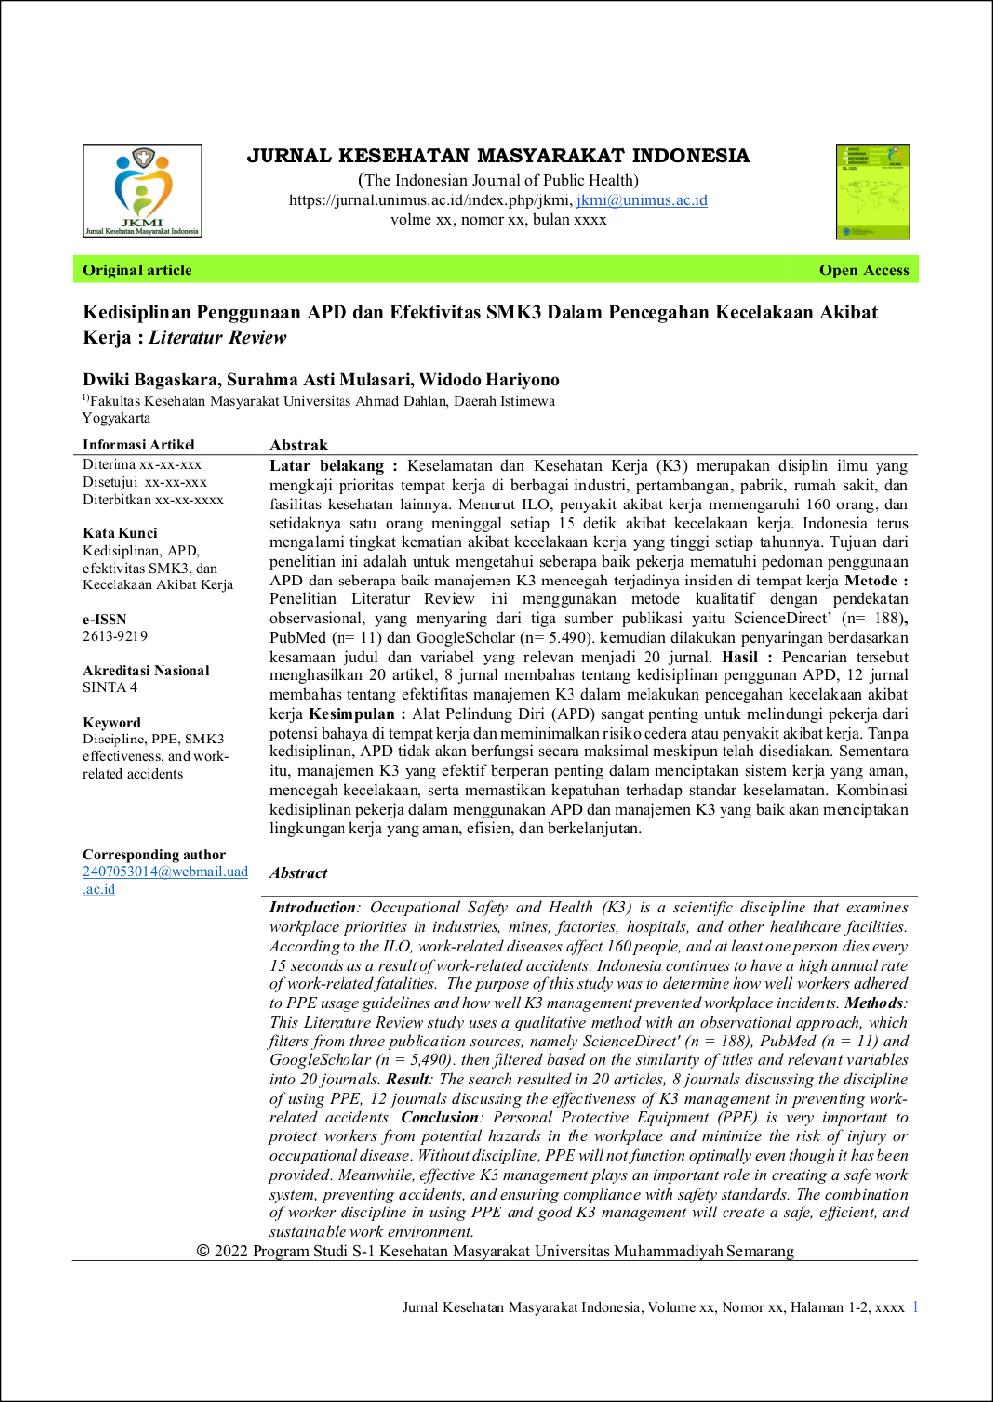
2
2
27
10
29
3
7
4
9
20

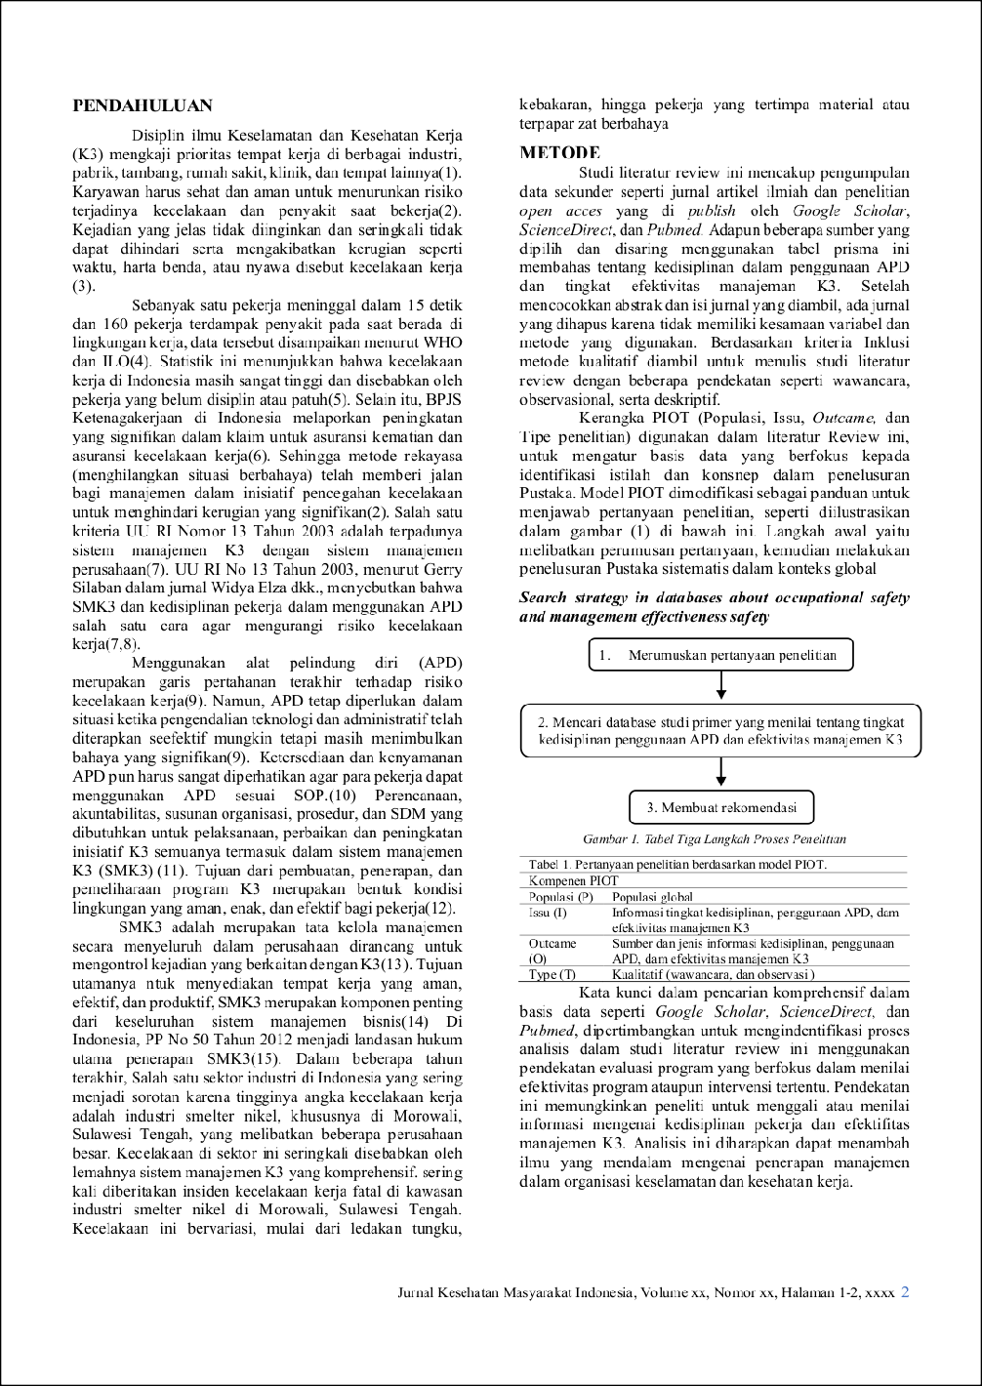
7
14
26
21
15

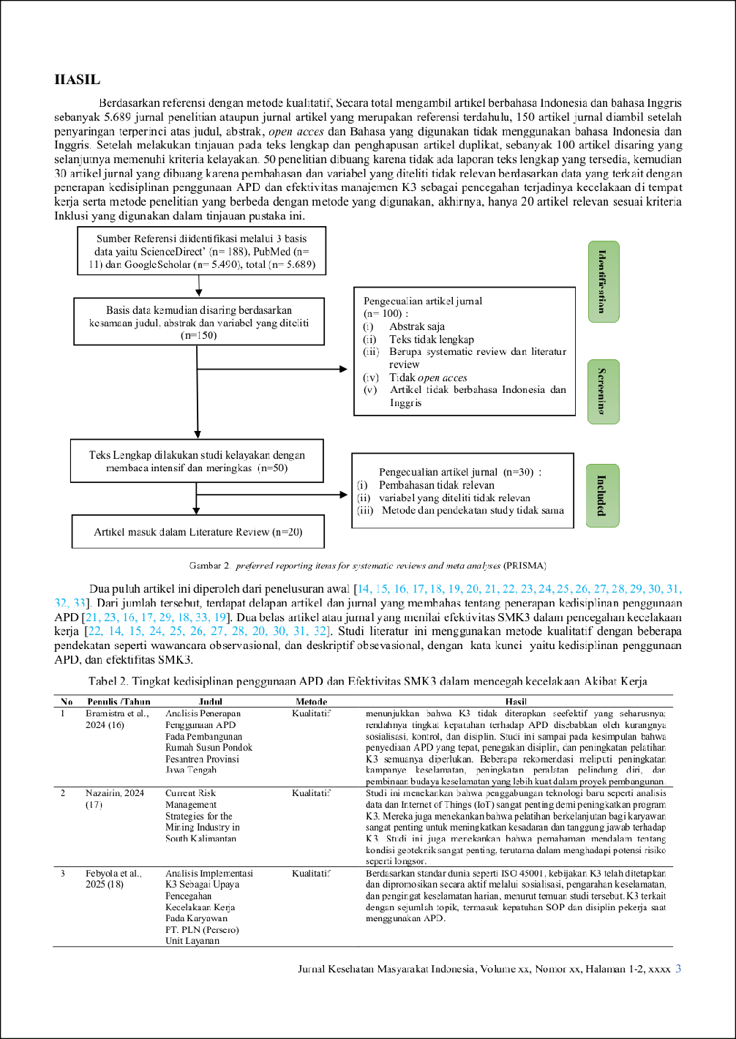
3
18
31
23
16

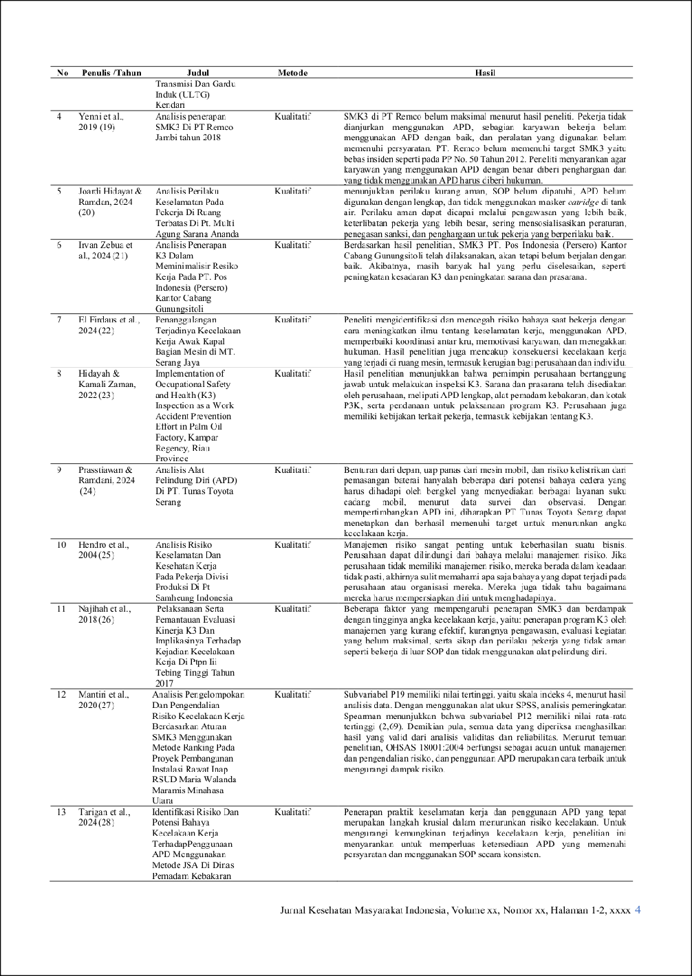
10
12
30
4
17
24
22
11
32
4
6

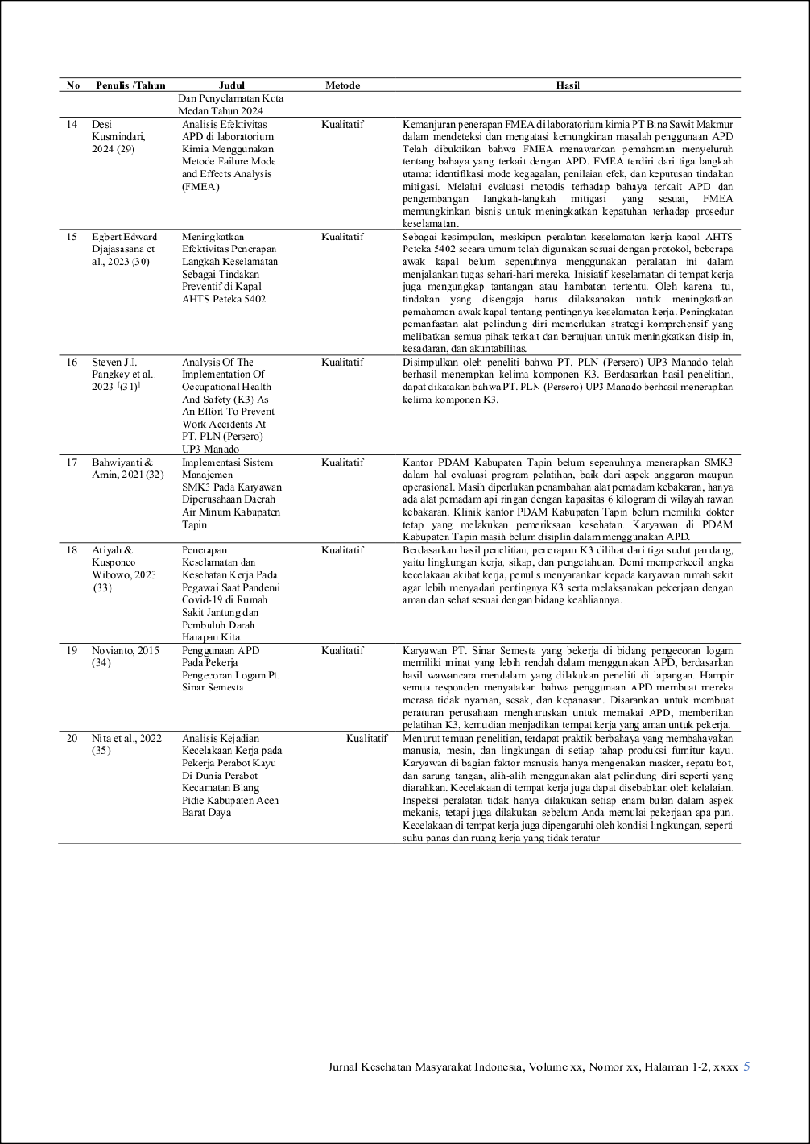
28
13
5
5
8
8
25

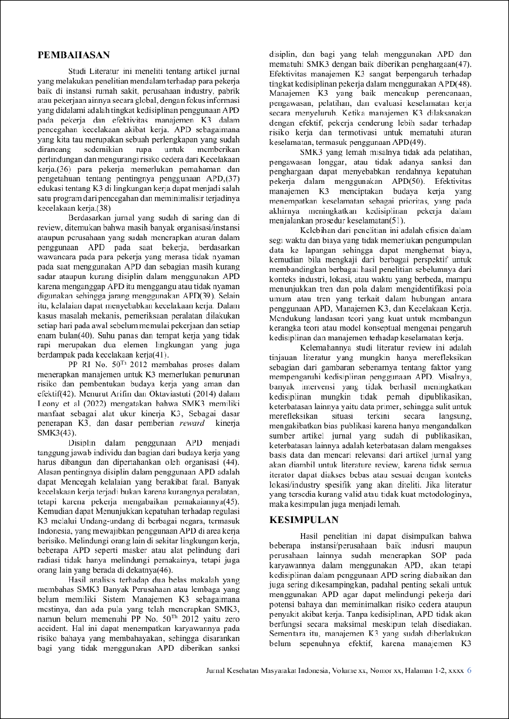

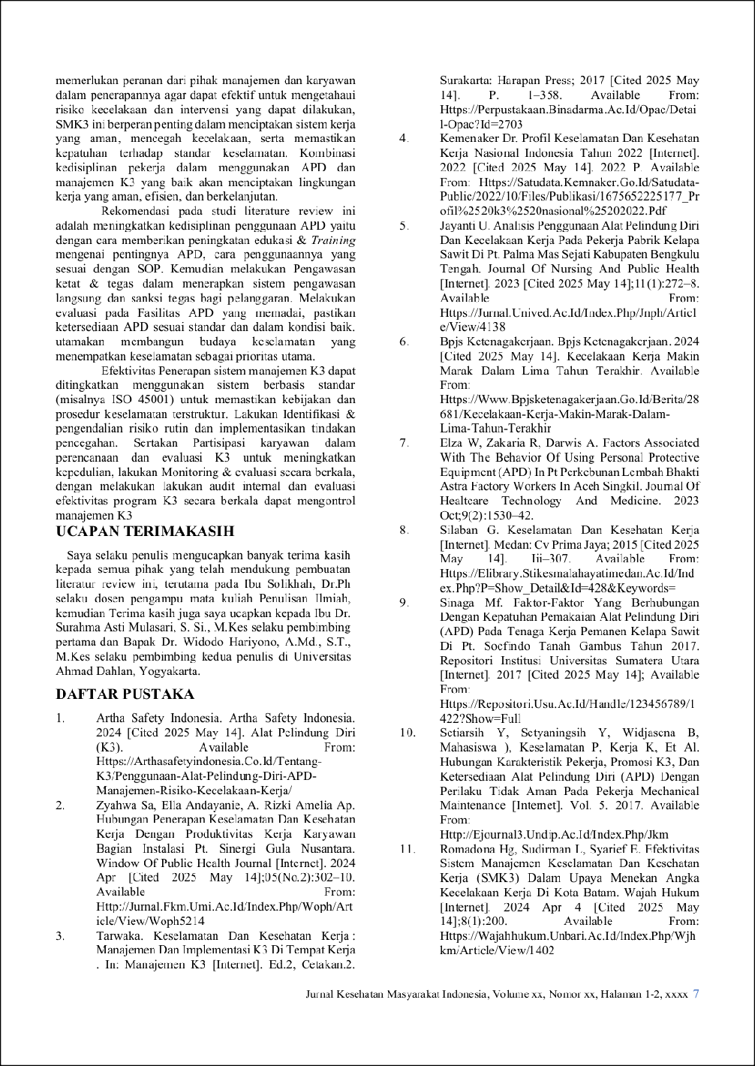
9
3
2
3
19

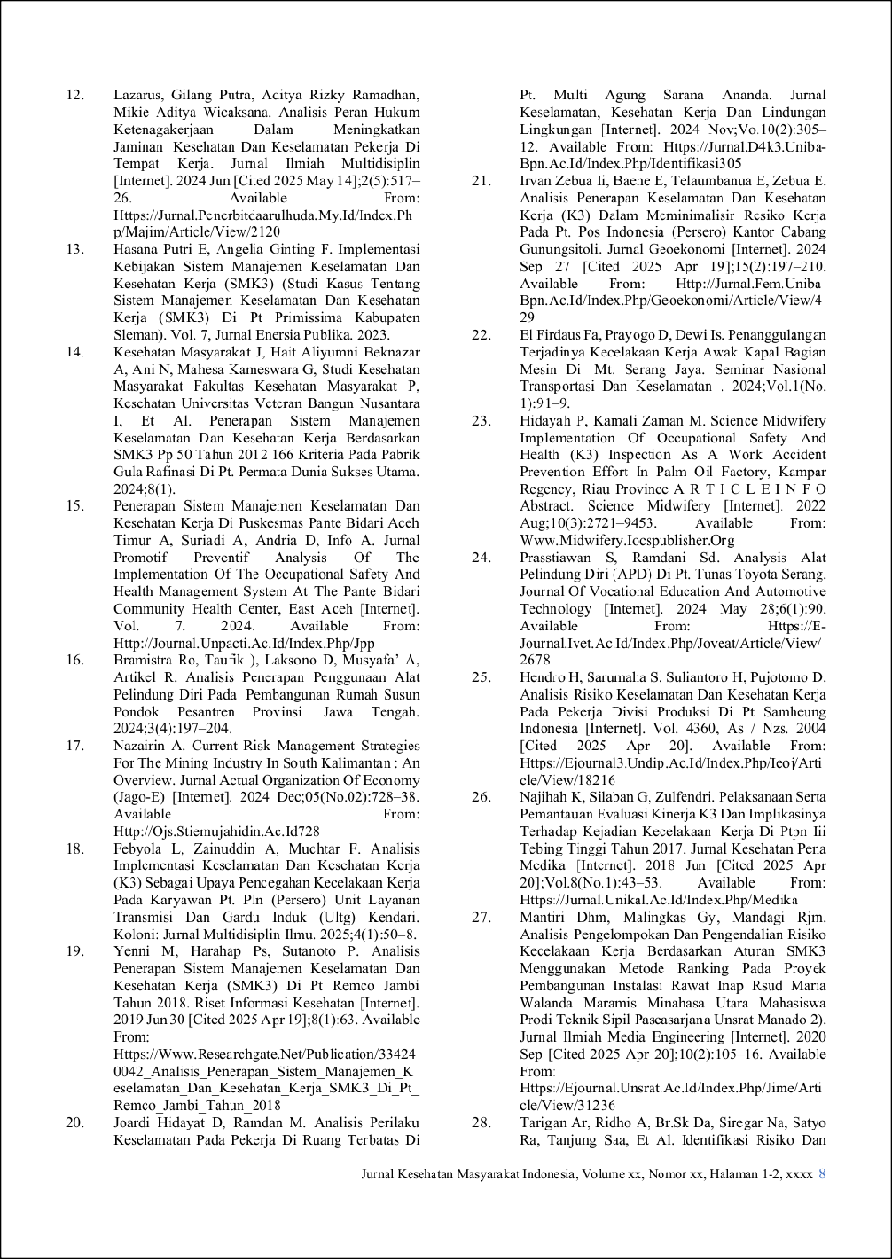

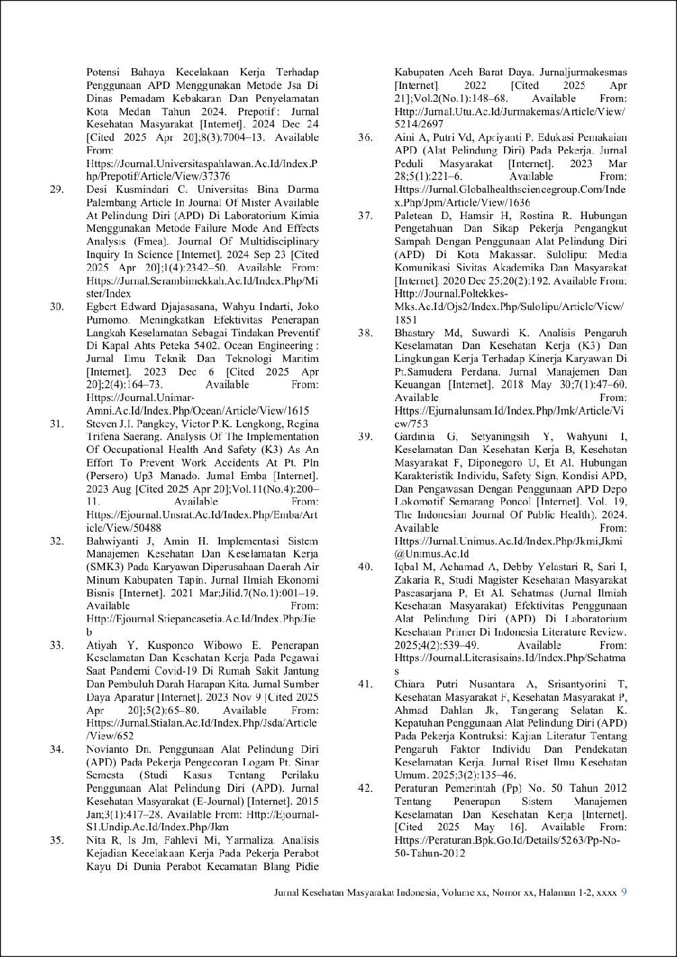

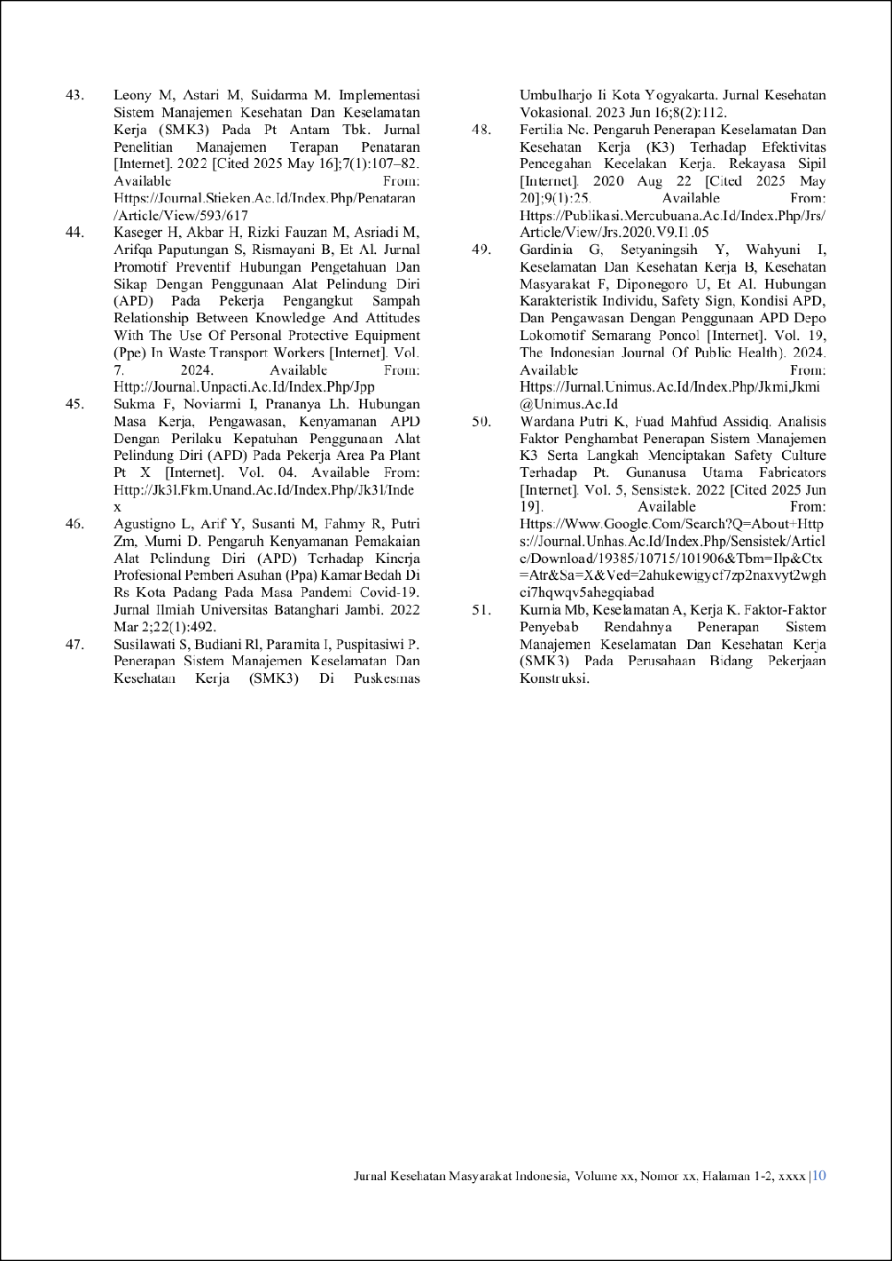

JKMI-literatur review Dwiki - PI.docx

ORIGINALITY REPORT
13

%
SIMILARITY INDEX
13%
INTERNET SOURCES
6%
PUBLICATIONS
5%
STUDENT PAPERS

PRIMARY SOURCES

1

2

3

4

5

6

7

8

9

10

11
Submitted to Surabaya University
Student Paper

eprints.uad.ac.id
Internet Source

jurnal.unimus.ac.id
Internet Source

journal.universitaspahlawan.ac.id
Internet Source

ejournal.unsrat.ac.id
Internet Source

jurnal.stikes-yrsds.ac.id
Internet Source

Arya Kusuma Widana. "IDENTIFIKASI BAHAYA DAN PENILAIAN RISIKO KESELAMATAN DAN KESEHATAN KERJA MENGGUNAKAN METODE HIRARC PADA GARDU INDUK AMPENAN",
Jurnal Informatika dan Teknik Elektro Terapan, 2024
Publication
123dok.com
Internet Source

id.scribd.com
Internet Source

www.coursehero.com
Internet Source

ejournal3.undip.ac.id
Internet Source
2%
2%
1%
1%
1%
1%
<1%

<1%
<1%
<1%
<1%

12

13

14

15

16

17

18

19

20

21

22

23

24

25
jurnal.d4k3.uniba-bpn.ac.id
Internet Source

journal.unimar-amni.ac.id
Internet Source

repository.poltekkesbengkulu.ac.id
Internet Source

Submitted to Universitas Lancang Kuning
Student Paper

koloni.or.id
Internet Source

repository.pip-semarang.ac.id
Internet Source

repository.unhas.ac.id
Internet Source

news.uad.ac.id
Internet Source

Hari Pranoto. "Manajemen Resiko Terkait Keselamatan Dan Kesehatan Dalam Proyek Konstruksi", Innovative: Journal Of Social
Science Research, 2024
Publication
digilib.uinsby.ac.id
Internet Source

e-journal.ivet.ac.id
Internet Source

eresearchjournal.transbahasa.co.id
Internet Source

garuda.kemdikbud.go.id
Internet Source

journal.unnes.ac.id
Internet Source
<1%
<1%
<1%
<1%
<1%
<1%
<1%
<1%
<1%

<1%
<1%
<1%
<1%
<1%

26

27

28

29

30

31

32
journal.unpacti.ac.id
Internet Source

repositori.usu.ac.id
Internet Source

eprints.undip.ac.id
Internet Source

jk3l.fkm.unand.ac.id
Internet Source

jurnal.fem.uniba-bpn.ac.id
Internet Source

repository.uin-suska.ac.id
Internet Source

www.jurnalstikesluwuraya.ac.id
Internet Source
<1%
<1%
<1%
<1%
<1%
<1%
<1%

Exclude quotes On Exclude bibliography On
Exclude matches Off

