To
Editorial Board of Jurnal Lensa
Faculty of Foreign Language and Culture
Universitas Muhammadiyah Semarang
Street Kedungmundu No.18
Semarang

STATEMENT LETTER
ETHICAL CLEARANCE

By submitting scientific papers/articles on my behalf/team to Jurnal Lensa, I hereby:

Name: Ulfatul Ma’rifah
Article Title: Technological Use in EFL Instruction: Investigating Teachers’ Pedagogical Beliefs and Students’ Learning Engagement
Institution: Universitas Muhammadiyah Gresik
Institution Address: Jl. Sumatera No.101, Gn. Malang, Randuagung, Kec. Kebomas, Kabupaten Gresik, Jawa Timur 61121
Phone: (031) 3951414/ 0822-2881-7918
e-mail: ulfamarifah@umg.ac.id

declare that the scientific paper/article that I submit is on my behalf or with a team, whose content is original or free from: a) fabrication; b) falsification; c) plagiarism; d) duplication; e) fragmentation; and f) violations data/content copyright. If in the future things are found that do not match my statement, I am willing to bear all the consequences/risks.

Gresik, 1/05/2020 Author,

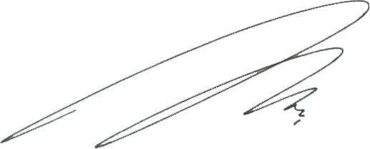

Ulfatul Ma’rifah,S.Pd.,M.Pd.
NIDN 0722028903

