To
Editorial Board of Jurnal Lensa
Faculty of Foreign Language and Culture
Universitas Muhammadiyah Semarang
Street Kedungmundu No.18
Semarang

STATEMENT LETTER
ETHICAL CLEARANCE

By submitting scientific papers/articles on my behalf/team to Jurnal Lensa, I hereby:

Name: Abdul Wachid B.S.
Article Title: The Concept Of Love And The Basis Of Its Doctrines Between Maqamat And Haal
Institution: Universitas Islam Negeri (UIN) Prof. K.H. Saifuddin Zuhri
Institution Address: Jalan A. Yani 40-A Purwokerto, Jawa Tengah, Indonesia
Phone: +62 811-303-136
e-mail: abdulwachidbs33@gmail.com

declare that the scientific paper/article that I submit is on my behalf or with a team, whose content is original or free from: a) fabrication; b) falsification; c) plagiarism; d) duplication; e) fragmentation; and f) violations data/content copyright. If in the future things are found that do not match my statement, I am willing to bear all the consequences/risks.
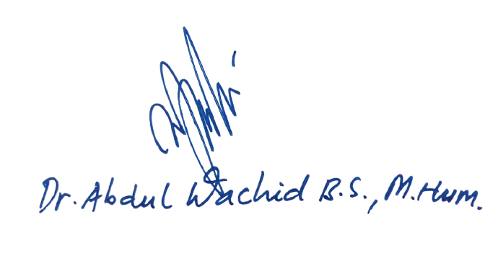
Purwokerto, 08/Juni/2021 Author,

NIDN 2007106601

