To
Editorial Board of Jurnal Lensa
Faculty of Foreign Language and Culture
Universitas Muhammadiyah Semarang
Street Kedungmundu No.18
Semarang

STATEMENT LETTER
ETHICAL CLEARANCE

By submitting scientific papers/articles on my behalf/team to Jurnal Lensa, I hereby:

Name: Yurike Suhertian Poyungi
Article Title: Translation Techniques of Modality Metaphor in Novel Anne of Green Gables
Institution: Sebelas Maret University
Institution Address: Surakarta
Phone: 081316623082
e-mail: yurikesuhertian@gmail.com

declare that the scientific paper/article that I submit is on my behalf or with a team, whose content is original or free from: a) fabrication; b) falsification; c) plagiarism; d) duplication; e) fragmentation; and f) violations data/content copyright. If in the future things are found that do not match my statement, I am willing to bear all the consequences/risks.

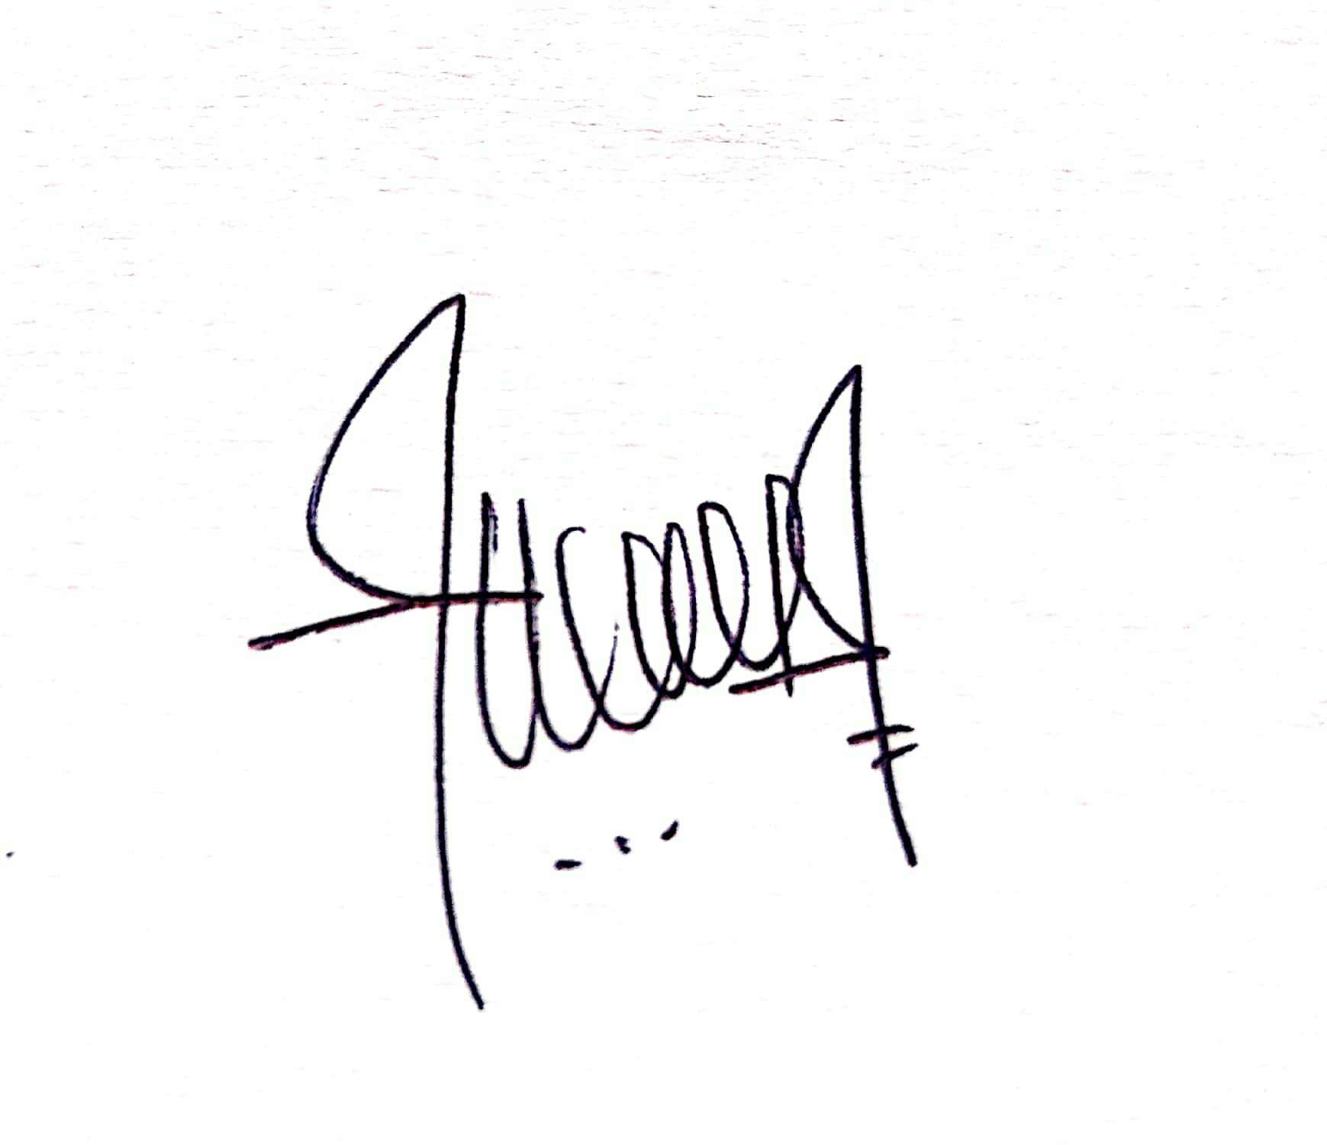
Surakarta, 08/06/2021 Author,

(Yurike Suhertian Poyungi)
NIDN .... (if any)

