**Ethnocentrism in Edward Zwick’s *The Last Samurai* Movie**

**Yogi Setyo Pradana,**

**Ali Mustofa**

Universitas Negeri Surabaya,

Jl. Lidah Wetan, Lakasantri, Surabaya

[yogi.17020154014@mhs.unesa.ac.id](mailto:yogi.17020154014@mhs.unesa.ac.id)

alimustofa@unesa.ac.id

**ABSTRACT**

This research focuses on ethnocentrism in Edward Zwick’s *The Last Samurai*. It is intended to identify how ethnocentrism is depicted and reflected in the life of samurai in the movie *The Last Samurai*. The ethnocentrism theory by William G. Sumner will be used to analyze the movie. Qualitatively, the data were obtained by watching the film, reading the movie script and cinematographic elements, identifying data based on the topic of study, and categorizing the data with respect to the theoretical framework. Based on the analysis, the findings show that there are three aspects of ethnocentrism; first, loyal to in-group norms; second, express in-group pride; third, judge and underestimate the out-group. These three features of ethnocentrism create a deep perception in their dominant culture to others*.*

**Keywords**: Ethnocentrism, Samurai, loyal, pride.

**INTRODUCTION**

Ethnocentrism is understood as someone's belief that one's group is the core of everything and the perception is important for particular group culture. Ethnocentrism is an attitudinal construct focus on this belief, and that, as an attitude, it also has strong emotional and behavioral aspects. It is profoundly embedded in the human condition and is most commonly present in all racial groups, albeit to varying degrees. Ethnocentrism is a mindset that includes values, feelings, and behaviors. Ethnocentrism has been with humanity since prehistoric societies, and it was still recognized by ancient philosophers, but it was only in the second quarter of the twentieth century that the term became incorporated into the social sciences. Since then, social scientists and a vast range of other academics have embraced the term.

Racism, prejudice, mental closure, and an oppressive personality system are also linked to ethnocentrism. It's commonly used in social and political science because it demonstrates a strong and readily recognizable mindset that can be measured legally. While ethnocentrism is linked to racism, it distinguishes it from racial prejudice in that it does not include a hostile attitude toward other cultures or races. (Permatasari et al., 2019) According to Graham Sumner, the view of certain group cultures can be known as vital things, while other group cultures are reduced to the lower status in the society.

Therefore, Culture is concerned with many different objects, both biological and physiological, as comportment, music, traditions and so on. As it affects several facets of life, it is seen in many different activities. Matsumoto describes culture because a group of people, though completely different with each individual, share their attitudes, ideals, convictions and conduct from one generation through to the next generation. (Matsumoto, 2002). Community is dealt with in reality through specific individuals or cultures. It reveals the somewhat different personality including its collective. There are many communities in society with their cultural specialty including people in ceremony, conduct, faith and attitude.

Ethnocentrism encourages in-group preferences in terms of interaction and solidarity, as well as outsider-group animosity. If one group does not tolerate the other, the people within this group assume that their group is preferable to the other. (Hooghe, 2008) Ethnocentrism is the belief that one's ethnic community or society is superior to that of other ethnic groups or cultures, and that one's cultural traditions should be extended fairly to other ethnic groups or societies. Ethnocentrism also believes that their philosophy, action, or mindset is the greatest in any way, even the most essential, right, and beautiful and that all cultures are inferior. People with this mindset are referred to as ethnocentric, and those they will judge the different communities from which they process knowledge if they are ethnocentric and intolerant. As a consequence, people believe that those who live their lives differently are immoral, unnatural, or in the wrong position.

Edward Zwick, the director of The Last Samurai, is well-known through his passion throughout managing but also his experience as a producer on television shows and films in the industry. In 1952, he was born in Chicago. Zwick began his career as a journalist at Rolling Stone after graduate from the AFI Conservatory in Los Angeles. He advanced his career and found work as a film producer, editor, and director in the television industry. The one discussed in this study The Last Samurai movie received four different Oscar nominations such as acting category, art direction, sound, and costume.

The Last Samurai movie is interesting to discuss American military officers train Japanese soldiers how to fight and battle against the samurai. Samurai is a legacy from their ancestors that has an important role in Japanese society. They have a preference that samurai culture is better than other cultures, this ethnocentrism is a main theme of The Last Samurai. (Hooghe, 2008) Marc Hooghe argues that social individuality approaches believe that ethnocentrism is the output of strong recognition toward in-group of someone, which directly leads to negative sense toward and underestimate of particular out-group members.

Furthermore, the research problem about ethnocentrism analyzes the standpoint that related to Japanese culture and western culture. This movie tells the story of an American soldier and samurai warrior who experiencing ethnocentric to their own culture. At the beginning of the story, Nathan Algren is known as US military officer employed to train the country's first new army by the Japanese Emperor. When the government tries to destroy the traditional Samurai warrior class to implement more westernized, commercial-friendly policies, it fails miserably, he is suddenly changed by his experiences with the Samurai, putting him in the middle of a fight between two ages and two continents. In the ring spectrum, Algren puts a recruit to the test. Algren thinks they aren't prepared to fight the samurai, so he goes up to one of the targets and warns a soldier that if he doesn't kill Algren, Algren will. The soldier is terrified and The scene shows that Algren wants to kill a samurai warrior by preparing the Japanese army. By this time, he becomes ethnocentric to japan culture because of the uniqueness of Japanese culture and to be a part of samurai until the end of the movie. He belongs to samurai to help samurai warrior in the war, that action showed ethnocentrism. He shows how well he had learned from his enemy the ways of the samurai.

The Last Samurai movie has previously been discussed by scholars. (Grajdian, 2020) Maria Grajdian, investigating reframing masculinity in the character embodied by Tom Cruise, a typical white male from a Japanese perspective showed an unexpectedly refreshing insight into the prevalent masculinity ideal in japan as subliminally suggested by the Japanese characters. Meanwhile, (Ingvason, 2017) Ingvason investigate the way of the warrior in modern Japan. The samurai is the Japanese version of a warrior who serves their lords with faith and loyalty, ready to give all their lives in the service of their lord. He claims that Japan's modernization pushed out the samurai and replaced them with new warfare.

However, in previous research, none of them discuss ethnocentrism issues in *The Last Samurai* movie. This discussion will investigate how ethnocentrism is depicted and reflected in samurai life. In this research, this article refers to Sumner’s theory of ethnocentrism. It employs her concept of ethnocentrism wherein loyal to in-group norms, express in-group pride and underestimate out-group are viewed as ethnocentric. These three concepts are most dominant in *The Last Samurai*.

**METHOD**

This research followed several stages. First, The Last Samurai movie was finished watching, with its contents fully understood. Second, read the script of the movie. Third, collected data are categorized and selected based on Sumner's theory of ethnocentrism. Fourth, selected data are analyzed and discussed in detail. The data analyzed using the content analysis of the whole story. The aspects found from the selected data are analyzed using the lenses of ethnocentric with a focus on the character Katsumoto and samurai warrior that show ethnocentric to their culture.

**FINDINGS AND DISCUSSION**

The Last Samurai is a story about a party of samurai in a deep mountain village. The main male character is Katsumoto, a samurai warrior chief tasked with defending the samurai colony. His colony is very proud of its samurai warriors, and they occasionally ban people from other countries. It can be seen in a variety of settings, including the home, culture, and how people treat their culture. Samurai are distinguished by their two swords, one long and one short. They are referred to as katana and wakizaki, respectively. They normally remain in their lords' castles and are also part of a military aristocracy household.

1. **Loyal to in-group norms**

Ethnocentric people will perform Loyalty. It is embodied by a commitment to in-group rules and honesty throughout relations towards fellow in-group members. Samurai had a unique routine which they practiced.. (Ingvason, 2017) The structured ritual of seppuku seems to have been a death ceremony in which samurai must disembowel themselves rather than commit suicide. It was often used by samurai who would rather die than face humiliation after defeat or the humiliation of imprisonment or torture at the hands of their opponents. Samurai would also do seppuku if they had defeated their lords, depending on the nature of their shortcomings, because samurai valued honor, strength, discipline, and devotion to their lord. The act of seppuku was a way for them to demonstrate their will, as well as to keep their honor and pride intact. Hara-kiri and seppuku share the same meaning in Japan, but seppuku is more often used because the Japanese synonym for seppuku is more prestigious. The first seppuku was mentioned sometime in the 12th century, but it became more common after a while because samurai believed that this was an honorable way to die to atone for their mistakes. If a samurai was ever sentenced to death, they had the option of committing seppuku rather than being disgraced by being executed by a commoner, so that their honor and pride would be preserved following their death. The quotes that reflect adherence to in-group standards are mentioned below.

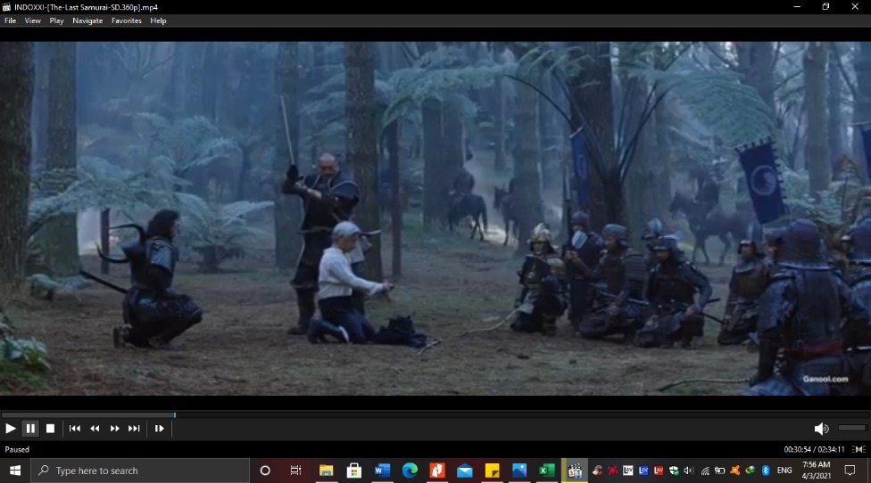

Picture 1: Katsumoto cuts the head of General Hasegawa.

*“Nathan: I've seen what you do to your enemies.”*

*“Katsumoto: Warriors in your country do not kill?”*

*“Nathan: They don't cut the heads off defeated, kneeling men.”*

*“Katsumoto: “General Hasegawa asked me to help him end his life. A Samurai cannot stand the shame of defeat. I was honored to cut off his head.”* (Logan, 2003)

In the quote above, Katsumoto claims that samurai may not bear the defeat embarrassment. As a samurai warrior, he thinks it a pleasure to shave General Hasegawa's head. Sumner claims that his society is equivalent to that of outgroups and that the latter is barbaric. His concept of ethnocentrism includes not only the advancement of one's race but also the development of discriminatory attitudes toward others. In the movie, Katsumoto lets Nathan alive to stay in his village. He let him live to learn about his enemy which is Nathan, who has a different culture. Nathan curious why Katsumoto let him live and stay in his village and don’t kill him such as general Hasegawa.

Furthermore, Katsumoto practices the samurai custom of only dying with his sword, as portrayed by him. “I will die by the sword,” he declares. “It's all mine.” He needs to die with dignity, according to the quote. He believes that if a samurai is humiliated by failure, he will kill himself with his sword rather than an enemy weapon. (Hooghe, 2008) Hoogart and Williams argue that they were interested in culture as the ‘texture of lived experience’ or a ‘structure of feeling’ rather than as a body of intellectual and artistic activities separate from the rest of society. The last scene shows his loyalty to the samurai. Adherence to in-group rules including trustworthiness throughout interactions with fellow in-group members are examples of loyalty. At the end of the war, he gives Katsumoto a sword to Japan emperor to remind him about the struggle of samurai. (*Hagakure: The Book of the Samurai - Yamamoto Tsunetomo - Google Books*, n.d.) Yamamoto argues that the way samurai is found in death when it comes with the choice. It is not particularly difficult. There will be always a quick choice of death. found in death Without achieving one's goal, a dog's death does seem to be a wasteful way of sophisticates.

The Japanese are stereotyped as possessing a personality that lacks a fully formed ego or sense of self-sufficiency. (Sugimoto, 2010) Doi claims that the concept of *amae*, which applies to the supposedly peculiar psychological tendency of Japanese people to achieve emotional fulfillment by winning over and relying on their superiors, is incorrect. They believe that no overt display of identity is needed. One of the most important values is community loyalty. Giving yourself to be obedient and achieve the group's aims brings a particular psychological fulfillment to the Japanese.

Therefore, an inability to comprehend the life or relationship of culturally diverse others. Perceptual distinctions for otherness are insufficiently detailed to allow segregation between various types of others, which might be viewed as "foreigners" or "minorities" or not at all. People perceive themselves as more "absolute" than others, even to the point where others may not appear entirely human, and the development for perceiving one's own culture is much more nuanced than those required for other cultures. As a result, people perceive themselves as more "real" than others. According to the samurai tradition, when a samurai feels humiliated by their defeat, they can destroy it with their blade, since this is the only way to die with pride.

1. **Express Group Pride**

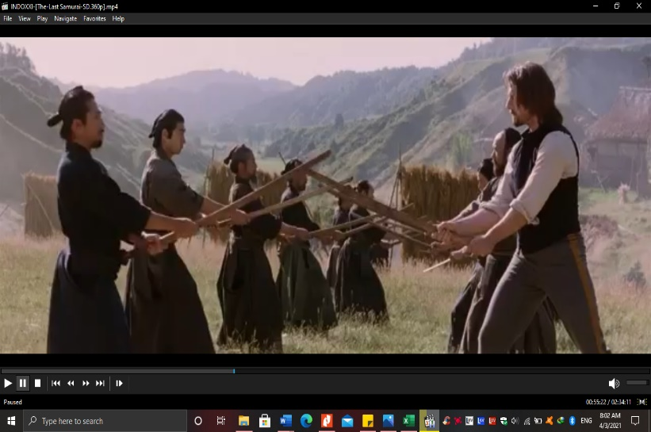According to experts such as Jandt and Gudykunst and Hooghe, ethnocentrism is the assumption that one race is superior to another. Since ethnocentrism considers one's community to be preferable, it causes people to compare and classify other cultures by that norm. (Zikargae, 2013). The following quotes reflect ethnocentrism, which leads people to believe that their society is the greatest and that they should be proud of it.

Picture 2: Samurai practice to use traditional sword.

*“Nathan: They are intriguing people. From the moment they wake...*

*... they devote themselves to the perfection of whatever they pursue.”*

*“I have never seen such discipline. I am surprised to learn that the word ''Samurai'' means ''to serve''...”*

*“... and that Katsumoto believes his rebellion to be...”*

*“... in the service of the Emperor.”* (Logan, 2003)

Although Nathan is not Japanese, he claims that the samurai community seems to be the preeminent culture. Most individual are willing to migrate to Greek and abandon their traditions since they claim samurai customs seem to be the most dominant. He says that samurai culture is very unique because it can attract him to learn about samurai. He praises the culture of samurai because Nathan never sees the discipline of the culture. Katsumoto as the leader of a samurai warrior believes that he is very proud to serve his emperor. (Neuliep et al., 2005) The statement by Neuliep that ethnocentric individual communicate well with members of their groups but disagree with members of a group corroborates this. Another quotation representing the depiction of pride in samurai culture. Katsumoto believes that his culture better than using other cultures, as follows,

*“Omura: Minister Katsumoto, it is with great regret...*

*... but I must ask you to remove your sword.”*

*“Katsumoto: This sword serves the Emperor. Only he can command me to remove it.*

*Omura: The Emperor's voice is too pure to be heard in this council.”*

*“Katsumoto: Then, I must refuse to give up my sword”* (Logan, 2003)*.*

From Katsumoto's statement, he shows that he is ethnocentric to his culture. He demonstrates a deep commitment to his culture and a sense of belonging in it. And he does not want to take off or give his sword. He resists changing the norm of samurai life to do not bring a weapon during the meeting because it is not samurai culture. Omura is the person who wants to change the culture of samurai. He wants to change the norm by using modern culture such as western culture but Katsumoto resists Omura's opinion even no one supports him. In a summary, ethnocentrism is the assumption that someone's community is superior to that of another.

1. **Judge and Underestimate Out Group**

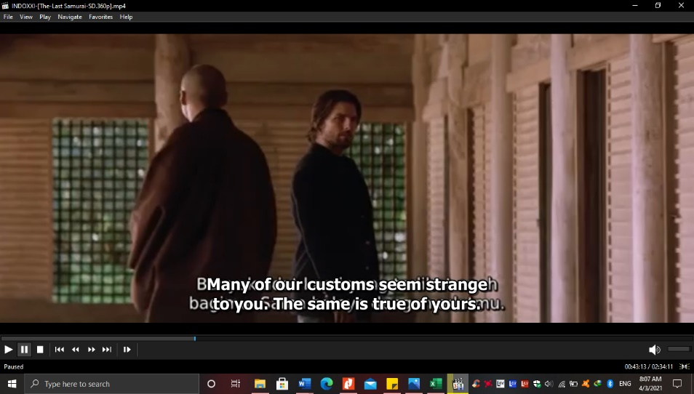 Individuals' propensity to see their ethnic community as proving the norms for appropriate attitudes and desires is known as ethnocentrism.. (Nurilaila et al., 2020) Individuals who are ethnocentric are intolerant and judgmental of civilizations other than their own. They take great pride in racial and ethnic identities of traditions, while sometimes despising the ideals of others.

Picture 3: Katsumoto judges western culture.

*“Katsumoto: Many of our customs seem strange to you. The same is true of yours. For example... ... not to introduce yourself is considered extremely rude, even among enemies”*(Logan, 2003)

The dialogues are between Katsumoto and Nathan when Nathan curious about what Katsumoto wants from him. In the beginning, Katsumoto introduces himself to Nathan but Nathan doesn’t answer it. Katsumoto wants to have a good conversation with Nathan by using English. in Japanese culture when someone meets with new people, they always bow and then introduce their name. Katsumoto sees the differences when meeting with an American soldier. He argues that enemy culture is extremely rude because he doesn’t want to introduce himself even among enemies.

Additionally, (Keith, 2015) ethnocentrism is often misinterpreted as a synonym for general antipathy against all out-groups, suggesting a denial of ethnic plurality, widespread discrimination for out-groups, and relational selection for in-group over most out-group, according to Berry and Kalin. Discrimination, xenophobia, misogyny, emotional restraint, and an oppressive personality arrangement are also behaviors associated with ethnocentrism. Ethnocentrism is characterized as in-group preferential treatment in terms of coordination and collaboration, as well as outsider-group animosity, which can contribute to intergroup conflict, aggression, or support for discriminatory acts. In brief, ethnocentric individuals are more egoistic yet they only consider their own civilization and are ignorant of other cultures. This contributes to prejudice towards other cultures, as well as judging things based on their own expectations and eliminating society from other traditions from their people's existence.

**CONCLUSION**

In The Last Samurai movie, the main character Katsumoto is constructed as ethnocentric. He is a leader of a samurai who has a responsibility to keep their ancestor culture. The spirit of samurai will not be omitted from the Japanese even the foreigners that want to modernize the culture of samurai. However, Ethnocentric is needed to protect our culture from the outside.

They perceive people from different cultural heritage with an attitude of otherness and in this manner, the powerful groups perceive that their culture tradition is better than other culture. Although the samurai culture has become a famous culture, yet exploitation of weaker communities at the hands of more powerful social and political agents is still a burning issue in different parts of the world. All social agents should accept and keep their culture because it is the legacy of the ancestors, especially for samurai culture.

Based on the analysis, this study has revealed some conclusions about ethnocentrism in Edward Zwick’s The Last Samurai movie. This research result finds that there are three sectors of ethnocentrism revealed in the movie. First, samurai tend to have a strong relationship with others, and they loyal to the group norm. second, expressing group prides through the culture of samurai that have special meaning. Third, they tend to underestimate the out-group because they perceive samurai culture are better than western culture. These three aspect effects happened because samurai want to maintain and keep their ancestor’s culture.

# REFERENCES

Grajdian, M. (2020). *Re-Framing Masculinity in Japan: Tom Cruise, The Last Samurai and the Fluid Metanarratives of History*. *16*(1), 50–64.

*Hagakure: The Book of the Samurai - Yamamoto Tsunetomo - Google Books*. (n.d.). Retrieved April 7, 2021, from https://books.google.co.id/books?hl=en&lr=&id=WuIImJ1kjnMC&oi=fnd&pg=PR7&dq=the+last+samurai&ots=Q4bIYNhZUu&sig=Mb5hwFUH60ZIqhnRYnjZYmQJkrY&redir_esc=y#v=onepage&q&f=false

Hooghe, M. (2008). Ethnocentrism. *International Encyclopedia of the Social Sciences*, 186–209. https://doi.org/10.4324/9780429275296-14

Ingvason, Þ. A. D. I. (2017). *Way of the Warrior in Modern Japan*.

Keith, K. D. (2015). Sumner, William G. (1840-1910). *The Wiley Blackwell Encyclopedia of Race, Ethnicity, and Nationalism*, 1–3. https://doi.org/10.1002/9781118663202.wberen352

Logan, J. (2003). The last samurai. In *Architectural Digest* (Vol. 60, Issue 11, p. 208).

Matsumoto, D. (2002). *Culture , Psychology , and Education*. *2*, 1–15.

Neuliep, J. W., Hintz, S. M., & McCroskey, J. C. (2005). The influence of ethnocentrism in organizational contexts: Perceptions of interviewee and managerial attractiveness, credibility, and effectiveness. *Communication Quarterly*, *53*(1), 41–56. https://doi.org/10.1080/01463370500055954

Nurilaila, E., Ricahyono, S., Setyadi, D., & Arifin, S. (2020). National Cultures and Politeness Strategies in Intercultural Communication Among Japanese and American Characters in “The Last Samurai” Movie: A Cross-Cultural Pragmatic Analysis. *Social Sciences, Humanities and Education Journal (SHE Journal)*, *1*(1), 10. https://doi.org/10.25273/she.v1i1.5853

Permatasari, R., Ayu, D., Sari, P., Islam, U., & Agung, S. (2019). *The Negative Effects of Ethnocentrism in My Big Fat Greek Wedding Movie*. *2*(0), 89–97.

Sugimoto, Y. (2010). *An Introduction to Japanese Society* (Third Edit). Cambridge University Press.

Zikargae, M. H. (2013). The Impacts of Ethnocentrism and Stereotype on Inter-Cultural Relations of Ethiopian Higher Education Students Mekonnen Hailemariam Zikargae, Bahir Dar University, Ethiopia. *Online Journal of Communication and Media Technologies*, *3*(4), 126–148.